Try to figure out what to do with Loreta. I don't know what to do, frankly. I mean, I know what I would do if I were in charge of the project, but I'm not. Apparently nobody is in charge and the project will somehow self-assemble.
I am to write five pages.
1. Home. The girls are sort of okay with what I've already done.
2. Corporate videos
3. Startup videos
4. Small business video marketing
5. Other stuff
There, that clears things up, right?
1015am
I'm trying to figure out what I'm writing about on Page 2.
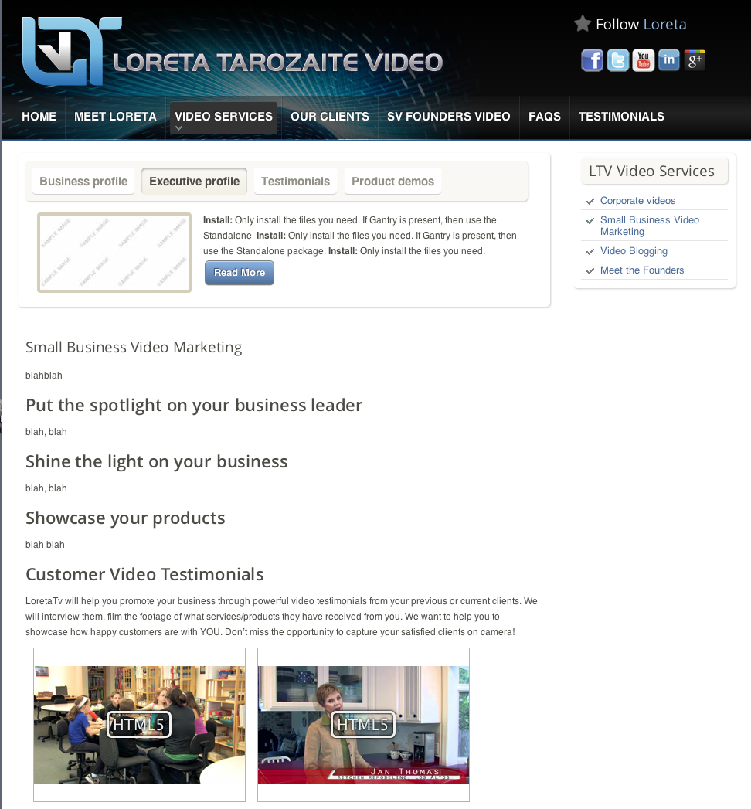
Kathy's layout shows four categories at the top: Business Profile, Executive Profile, Testimonials, and Product Demos. Each category shows a thumbnail of a video, and the categories dynamically slide aside every five seconds in rotation.
Under the rotation we see four headlines. Each of them is related to one of the categories. At the bottom of the page, Kathy has placed two larger video thumbnails for the TESTIMONIALS category.
However: now I'm told that there will be no individual videos. Instead there will be four videos, each one a random selection from Loreta's portfolio, and I'm not to worry about exactly which videos go where, or what the videos are designed to accomplish.
There are no other pictures other than the four videos. This is not good for visitor interest. I'm looking at the maximizeVideo.com site, and they have zero active videos on their home page, and 8 still photos that lead to other pages, and the rotating banner displays 8 more stills.
1050am
I guess I'll just have to patch together my ideas about how the site should look.
1150am
Okay, here's my slapped-together idea.
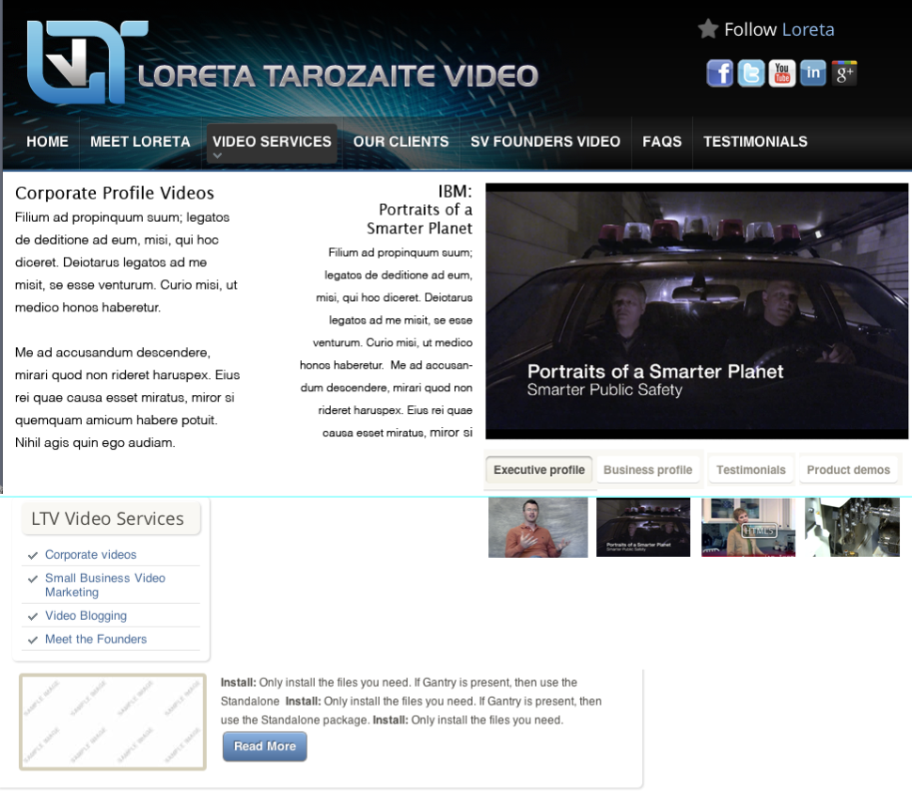
Not that I'm redesigning the site.
445pm
Got a call from Kathy Long--first time I've heard from her in weeks. She wanted to talk about the email I sent, except she hasn't read it yet. She didn't want to bother reading it, we could just talk it out.
The main thing is that I don't know what I'm writing about. I finally got it through Kathy's head. She told me it doesn't matter, I can write about anything, and I said no, I have to know what the people are looking at on the page so I can make the text underline the points that the videos are making.

